- GT4I – stands for the hugely popular E-Book/Scam product “Grow Taller 4 Idiots”. You can download it in PDF form from many websites.
- LSJL – Lateral Synovial Joint Loading – just do a search on the website to learn more about this.
- Ghen – stands for Ghenerate, which has been a type of pill sold on the internet which is supposed to increase the level of GH in the body.
- IGH1 – stands for IGH-1, which was a type of pill that was sold on the internet
- CPM1 – is Closed Plates Method 1 – This included LSJL
- CPM2 – stands for Closed Plates Method 2 – this method was supposed to possibly regenerate back the growth plates.
- MOD GRF – Modified Growth hormone Releasing Factor – a 29 amino acid peptide analog of Growth-hormone-releasing hormone
- GHRP2 – Growth Hormone Related Peptide Type 2 – stimulates the pituitary gland’s production of human growth hormone (HGH)
Alkoclar’s main way to increase height was to increase the CNP and Nitric Oxide expression, and that was where the the Methylprotodioscin came in
CNP overexpression increased height. Both NO and CNP cause the upregulation of cGMP. cGMP increases hypertrophic differentiation…But if cGMP can increase height then Viagra can increase height by inhibiting PDE5 which inhibits cGMP

Proteins and genes that affect
Endochondral ossification process
Chondrogensis process
Hormone Signaling process

Increase CNP expression
Increase Nitric Oxide expression
Expression of Kidney Growth Secreted Factors
Collage 2

Bone Morphogenic Proteins!
BMP-2

IGF-1 in addition to (Lithium Orotate and Microfractures)

Pi3K
IGF-1
Chondrocyte Proliferation
Keep feedback loop negative

Methylprotodioscin and Desmethylicaritin, or Dimethylicaritin

(Tribulus Terrestris and Glycine Propionyl L-Carnitine)
Horny Goatweed

Pills that may help:
Folic Acid and Folinic Acid
Glucosamine Chondroitin
MSM
Melatonin

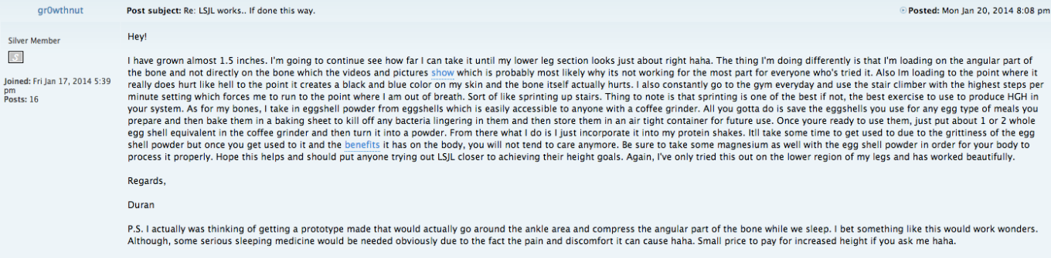

Did not workout heavy weights, did intense cardio

Research
“Pi3k pathway and bone growth”
“MSM Chondroitin Chondrocytes pubmed”

(+) Potent Pi3k activator
(+) Increase DNA Methylation
(-) Somatostatin Inhibitor
(+) Increase Chondrocyte Proliferation

Get Methylprotodioscin and Desmethylicaritin that are pure
(Methylprotodioscin myostatin 3.7-bis (2-hydroxyethyl) icaritin

(+) increase cGMP
(+) increase osteoblast proliferation
(+) induce chondrocyte differentiation
(-) suppress aromatase activity
(-) inhibit myostatin
(+) increase CNP expression

Concentrate on CNP and FGF-2 Production. CNP alone won’t increase height.

Puerarin, Ghenerate, IGH-1, Hexarelin

(+) increase serum levels of cGMP
(Nitric Oxide and Guanyl Cyclase)

( -) inhibit cGMP inhibitors (PDE5 inhibited by Viagra)

Hexarelin 50 mcg → morning (potent pi3k activator)
DNA methylation → SAM-e, MSM, Chondroitin

Huperzine A (when taken Hexarelin) Huperzine A is somatostatin inhibitor
Niacin 500 mcg before bed
Melatonin 3 mg before bed

Chondrocyte hypertrophy

Methanol → CH₃OH
Protodioscin → C₅₁H₈₄O₂₂
Methyl → CH₃ (alkylation)

Dimethylation → reversal of Methylation ➔ replacement of a methyl group by hydrogen atom → Net loss of one carbon and two hydrogen atoms.
CH₃ (methyl) + C₅₁H₈₄O₂₂ (protodioscin) ➔ C₅₂H₈₆O₂₂ (Methylprotodioscin)

DESmethy icaritin → C₂₀H₁₈O₆

Icaritin → C₂₁H₂₀O₆

C₂₁H₂₀O₆ – CH₃ = C₂₀H₁₈O₆

Icaritin – methyl = Desmethylicaritin

Icariin → C₃₃H₄₀O₁₅

Growth plates never seal but become inactive and to re-active, take MSM & Chondroitin and SAM-e (enteric coated tablets). This increases DNA Methylation. Apparently combining MSM with SAM-e helps possibly get the body to grow after epiphyseal plate ossification.

Hex will make you tall when your growth plates are inactive but it will make you VERY tall when your growth plates are active.

GHRP-2 and CJC 1295 are supposed to increase GH and IGF-1 productions.

Growing factors:

Pi3K, IGF-1, Chondrocyte Proliferation, Sleep and Jumping type of exercises (sprinting)

MENS routine (Melatonin, Exercise, Niacin, Sleep)

Stay away from strawberries, tomatoes, and bananas

Positive Feedback Loop
Negative Feedback Loop

Expectation:

SAM-e (2000 mg) + folinic acid (800 mg) + Ghenerate (ass fast absorption) = 0.75 cm
IGF-1 + LSJL + Microfracture (Sprinting) + Lithium = 1 cm
Melatonin + Exercise + Niacin + Sleep = 0.5 cm
Glucosamine Sulfate (massive amount) + Egg Shells + LSJL = 0.75 cm
SAM-e (2000 mg) + MSM (1000 mg) = 1 cm
IGF1 + Lithium + Ghenerate (ass fast absorption) = 0.5 cm

Most of the height genes are linked to HMGA2, CNP, FGFR3, and IGF2.

Top 5 growth factors we need at BMP2, BMP7, some FGF (not sure which type), IHH, and IGF-1.

it is found that BMP6 and BMP9 may be slightly better than BMP2 and BMP7 on certain parts.

DLPA (DL-Phenylalanine)
Ginseng
Lecithin
DHEA

Take everyday (combination) and possibly grow 1 inch.

The Methylprotodioscin , Icariin, Niacin, GPLC routine

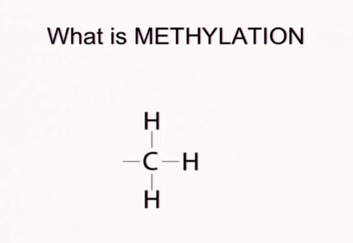

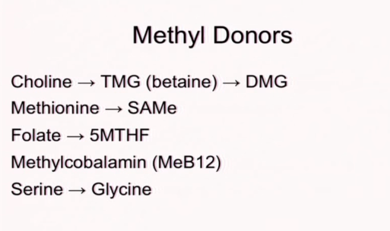

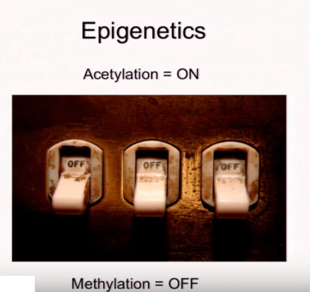

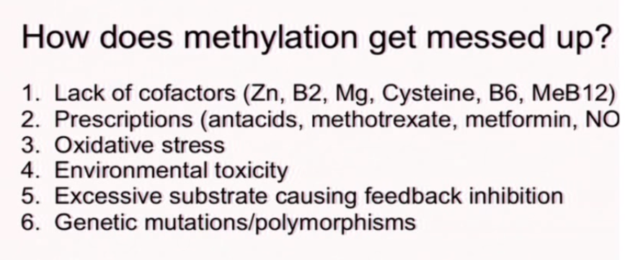

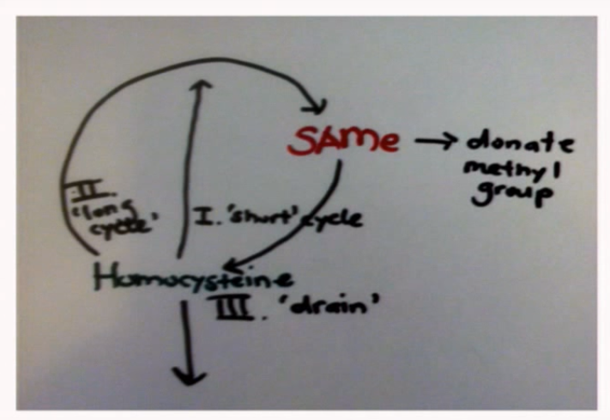

The following is a list of methyl donor supplements that may be of benefit in the treatment of epigenetic disorders:
SAM-e is considered the “master methyl donor.”
Choline.
Folic acid.
Methionine amino acid.
Vitamin B complex.
The following foods are good methyl donors:
Apples.
Citrus fruit.
Tomatoes.

